Conversational Ai Chatbot using Python and

Natural Language Processing

Palli Yani Grace
Department of Computer Science and Engineering
Bapatla Engineering College
(Autonomous)
(Affiliated to Acharya Nagarjuna University)
Bapatla, India
yanigrace2003@gmail.com
MERIGA HARIKA
Department of Computer Science and Engineering
Bapatla Engineering College
(Autonomous)
(Affiliated to Acharya Nagarjuna University)
Bapatla, India
harikahd777@gmail.com
Gonugunta Anjali
Department of Computer Science and Engineering
Bapatla Engineering College
(Autonomous)
(Affiliated to Acharya Nagarjuna University)
Bapatla, India
gonuguntaanjali99@gmail.com

Korapati Ajay
Department of Computer Science and Engineering
Bapatla Engineering College
(Autonomous)
(Affiliated to Acharya Nagarjuna University)
Bapatla, India
Korapatiajay1@gmail.com

Abstract— The days of solely engaging with a service through a keyboard are over. Users interact with systems more and more through chatbots. A chatbot is an intelligent piece of software that can communicate and performing actions similar to human. This software is used to perform tasks such as quickly responding to users, informing them, helping to purchase products and providing better service to Customers. Every time the chatbot gets input from the user, it saves input and response which helps chatbot with little initial knowledge to evolve using gathered responses. With increased responses, precision of the chatbot also gets increases. The ultimate goal of this project is to develop a chatbot that could answer student queries. The program selects the closest matching response from closest matching statement that matches input utilizing WordNet, it then chooses response from known selection of statements for that response. The well-known chatbots currently are Apple's Siri, Amazon's Alexa, Microsoft's Cortana and Google Assistant.
Keywords— Recommender systems, natural language processing, sentiment analysis, cellular phones, reviews, decisionmaking, text mining, web mining

Introduction
A chatbot is an Artificial person or other creature which holds conversations with humans. This could be a text based(typed)conversations, a spoken conversation or even a non-Verbal conversation. Chatbot can run on local computers and phones though most of the time it is accessed through the internet. Chatbot appears everywhere from old ancient HTML pages to modern advanced social networking websites. There are some hybrid strategies and adaptive techniques that make increasingly complex techniques. A chatbot program that copies human discussions including content and communication picture and video processing, and voice analysis. This chatbot system is an internet application that gives an answer to the broken-down queries of an user. Users simply need to choose the classification for inquiries and afterward ask the question to the bot that utilizes for noting it. Then the user can procure the fitting solutions to their inquiries. The creation and implementation of chatbot is still a developing area, heavily related to python so the provided solutions, while possessing obvious advantages have some important limitations in terms of functionalities and use cases. However, this is changing over time. As the knowledgebase used for the output generation is fixed and limited, chatbots can fail while dealing with an unsaved query. But this chatbot cannot fail the user can the type the query if the query does not match with data so chatbot will message. Ido not understand your question. Analytics are often overlooked and underappreciated when it comes to chatbots. while chatbot analytics are unlikely to make or break the success of a chatbot they can provide valuable insight into opportunities for information about data allowing chatbot can help reply with text of users. The system answers to users queries with the assistance of effective Interfaces. There are many so popular chatbots in marketing for eg:Alexa it works in the voice bot that resulted in largest revenues in our chatbot reply with text form and quickly reply all information from the data.

METHODOLOGY

Generative AI
Generative AI, a subset of artificial intelligence, revolves around the creation of new content, data, or media that mimics human-like creativity and imagination. Unlike traditional AI systems that primarily analyze and interpret existing data, generative AI has the capability to generate entirely novel outputs based on the patterns and structures it has learned from vast datasets.

At its core, generative AI operates through complex algorithms, often leveraging deep learning techniques such as neural networks. These algorithms are trained on large datasets of examples, whether it's images, text, music, or other forms of data, to learn the underlying patterns and relationships. Once trained, the generative AI model can generate new instances of data that resemble the training examples, yet are unique and original.

Generative AI finds applications across a wide range of domains. In art and creativity, it can produce stunning visual artworks, compose music, or even write literature that captures the essence of human expression. In language processing, it can generate coherent and contextually relevant text, powering applications like chatbots, language translation, and content generation.

One of the most prominent examples of generative AI is the generative adversarial network (GAN). In a GAN framework, two neural networks, the generator and the discriminator, are pitted against each other in a competition. The generator generates samples while the discriminator evaluates them for authenticity. Through this adversarial process, the generator improves over time, producing outputs that become increasingly indistinguishable from real data.

Generative AI holds immense potential but also raises ethical considerations, particularly regarding the generation of realistic but synthetic content, which could be misused for malicious purposes such as spreading disinformation or creating deepfake videos. As generative AI continues to advance, it is crucial to navigate these ethical challenges while harnessing its capabilities for positive innovation and creativity.

NLP
Natural Language Processing (NLP) is integral to the development of chatbots due to its role in enabling these AI systems to understand and interpret human language. Through NLP, chatbots can effectively analyze the structure, semantics, and context of user messages, allowing them to accurately recognize user intents and extract important entities. This capability not only facilitates the generation of relevant and meaningful responses but also enables chatbots to maintain context throughout a conversation, resulting in more coherent interactions. Furthermore, NLP enables chatbots to personalize responses based on user preferences, learn from past interactions to improve over time, and support multilingual communication, making them versatile tools for engaging with diverse user populations across various domains and industries. Ultimately, NLP empowers chatbots to provide intelligent, natural, and user-friendly conversational experiences, driving enhanced customer satisfaction and engagement.

LLM
"LLM in Python for chatbot development involves utilizing the Python programming language and various natural language processing libraries to create conversational agents known as chatbots. These chatbots can understand and respond to user input in natural language, enabling human-like interactions in various applications such as customer service, virtual assistants, and information retrieval systems

Proposed Model:
This chatbot is created by using Python, Natural Language Processing, Generative AI model and various API’s. When a user asks a query the chatbot is able to retrieve information from the pre-trained model and from the additional knowledge. It also enables user to interact and ask queries through voice. we aim to develop an advanced chatbot that seamlessly integrates user-uploaded knowledge from PDF documents into its response generation process. Leveraging Natural Language Processing (NLP), Generative AI, and Large Language Models (LLMs), the chatbot will offer users comprehensive and accurate answers to their queries by drawing upon both its existing knowledge base and the additional information provided through PDF uploads.

Architecture:
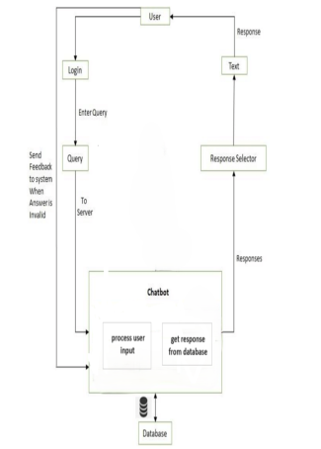

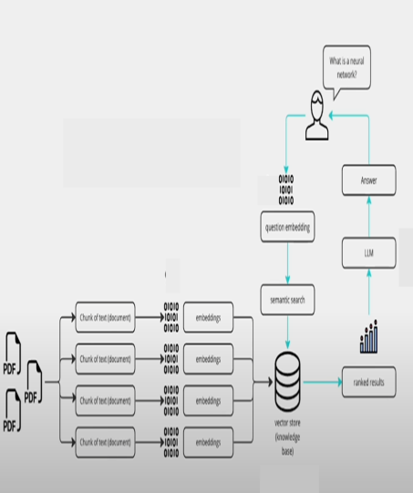

In the architecture of proposed system, user will open the application, upload the additional knowledge through PDF’s and queries the chatbot. Later this query is processed by chatbot and searched through big knowledge base for response. It will do the similarity search across the database and the highly similar response will be chosen as response. Meanwhile the additional knowledge is being processed , converted into embeddings and then stored in a vector store. when user asks a query, the query also converted into embeddings and the question embeddings are matched with the vector store data through semantic search. The highly matched or highly ranked data got chosen as response using LLM.At last the both responses are combined and displayed to the user.

VII RESULTS:

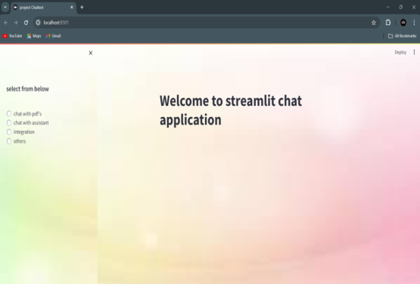

Figure 7.1 Welcome Page

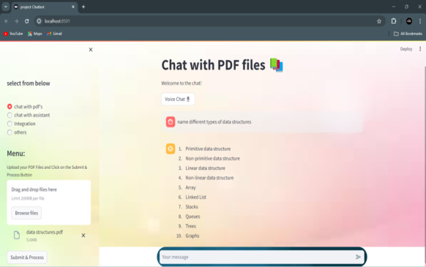

Figure 7.2 Chat With PDF Files
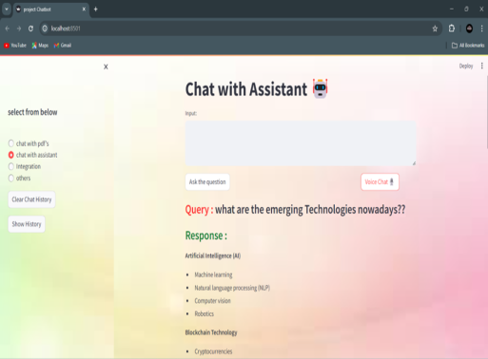

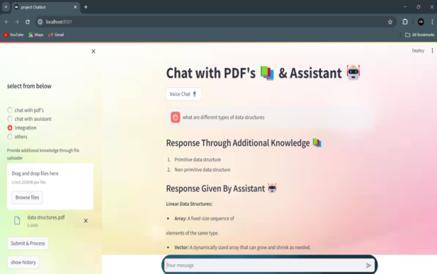

VIII CONCLUSION
This chatbot meets the target goal for creating a chatbot that process additional knowledge from the user and generate responses.
This chatbot is adaptable for future usage and can be integrated with other systems or applications. It can be used in IT industries, Educational institutions, General public, and it can be also integrated into E-Commerce websites.

IX FUTURE SCOPE
This versatile system is engineered for effortless integration into a multitude of websites, making it an invaluable asset across numerous sectors, including education and beyond. Its adaptability enables seamless incorporation into diverse platforms, amplifying its utility and impact across various industries and fields. Whether deployed in educational institutions to enhance learning experiences or integrated into other sectors for optimized functionality, this application promises to deliver tailored solutions to meet a wide array of needs, ensuring efficiency and effectiveness wherever it is implemented.
Acknowledgement

The authors would like to thank Ass. Prof. ------- Bapatla Engineering College, Bapatla for guiding throughout the work and the authors would also thank research paper writers for providing base to our Work

.References
1] Sethunya R Joseph Et al., “Natural Language Processing; a Review”, International Journal of Research in Engineering and Applied Sciences, 2016.
[2] Rishabh Shah Et al., “An Intelligent Chatbot using Natural Language Processing”, International Journal of Engineering Research, 2017.
[3] Meet Popat Et al., “Alexis: A Voicebased Chatbot using Natural Language Processing”, International Journal of Engineering Research and Technology, 2022.
[4] Mohammed Benhmed Et al., “A Smart Chatbot Architecture based NLP and Machine Learning for Health Care Assistance”, International Journal of Advanced Computer Science and Applications, 2015.
[5] Tarun Lalwani Et al., “Implementation of a Chat Bot using Natural Language Processing”, International Journal of Innovative Research in Computer Science and Technology, 2018.
[6] Philip Indra Prayitno, Et al., “Healthcare Chat Bot using Natural Language Processing”, 1st International Conference on Computer Science and Artificial Intelligence (ICCSAI), 2021.
[7] Jesse Vig Et al., “Investigating Gender Bias using Casual Mediation Analysis”, Neural Information Processing Systems, 2020

